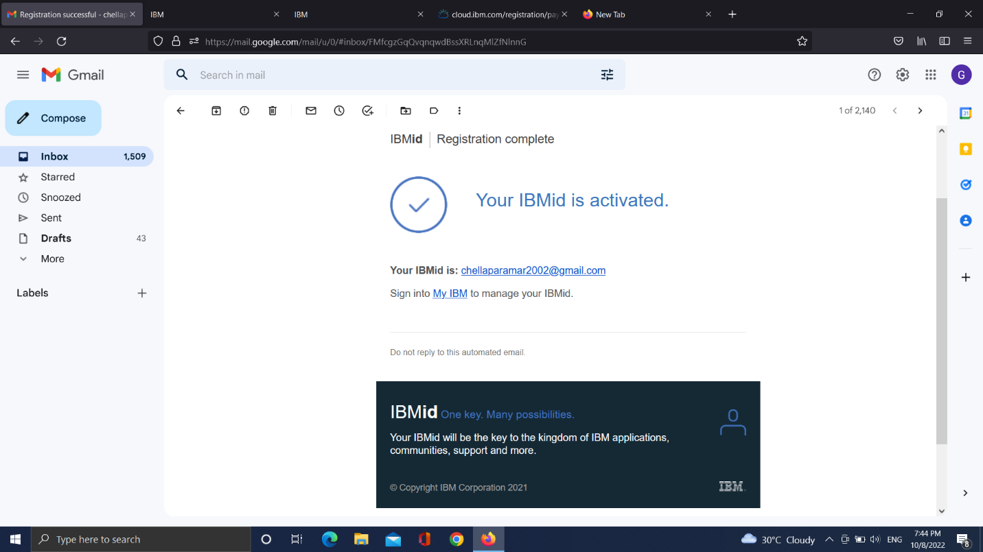

Task 1 IBM CLOUD SERVICE has been successfully completed.